**Data Model**

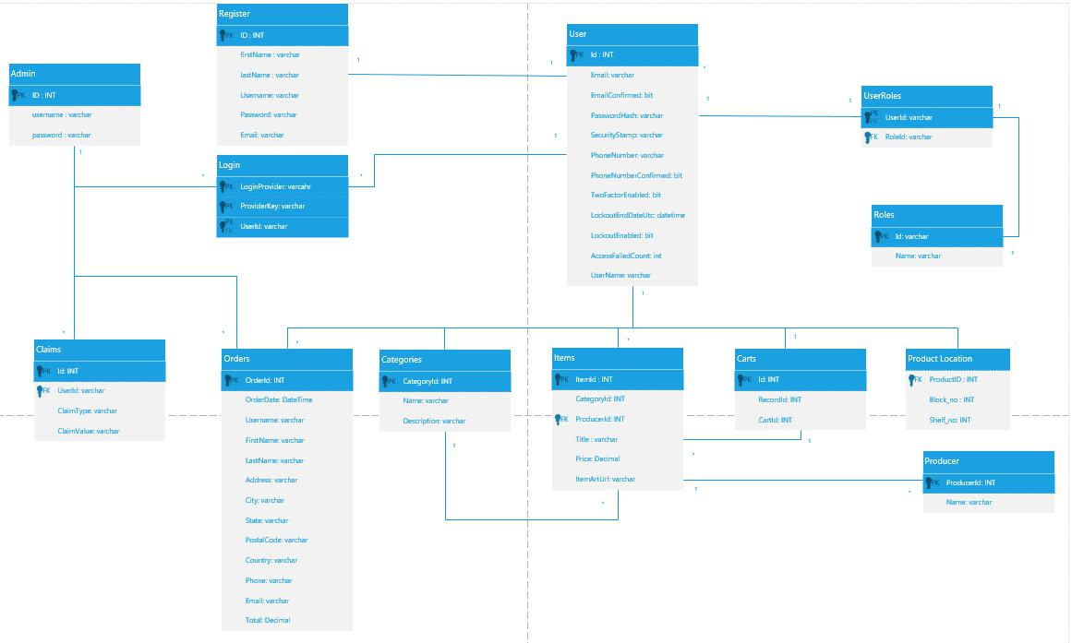

**ER Diagram**

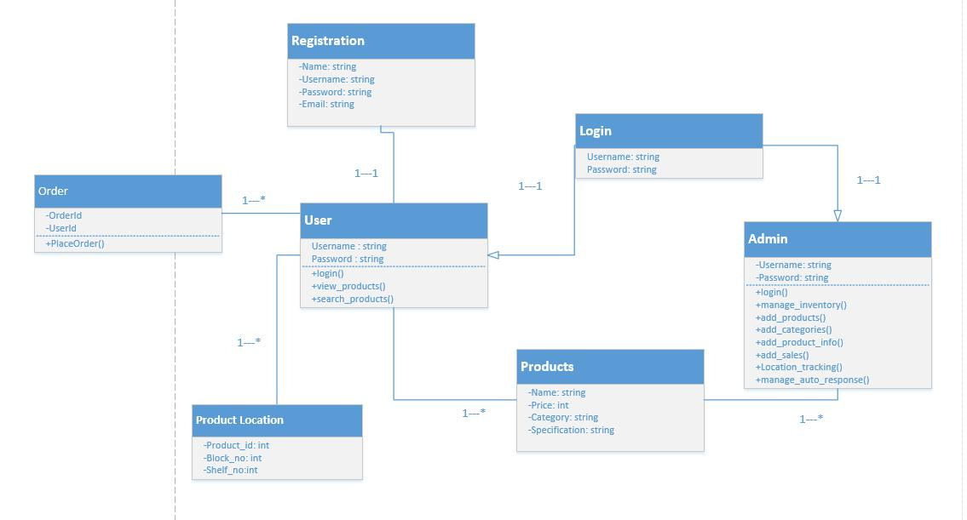

**Tools and Technology with reasoning:**

**Technology and Languages**

**Bootstrap**

To design website layout and structure, HTML, CSS, and JavaScript these languages will be used

**PHP**

For back end coding php will be used

**Java**

For back end coding in android studio java will be used

**Application Tools**

**XAMPP**

For coding Php language Visual Studio will be used

**Android studio**

For coding in java android studio is used.

**API**

API is used to get response from server.

**Web Server**

Web server is required for responding to the requests of clients

**Database**

**MySQL**

MySQL will be used for Database Design and Development

**Microsoft Visio**

Microsoft Visio is used for Project Design and Diagrams

**Microsoft word**

Microsoft word is used for designing documentation